**WEATHER APP**

Introduction:

This is a simple weather app which we can easy to receive the weather conditions in your current location. Weather forecast app provides detailed local forecast & weather forecast world-wide, the app provides the current temperature in Celsius and Fahrenheit, sunrise and sunset time according to city time zone.

**Domain:**

This project is used to build with the following domain

* HTML
* CSS
* JavaScript

**API:**

For this project I have used the api from an open source which is called open weather app which I get the api and the api key with the help of that we get information about the weather

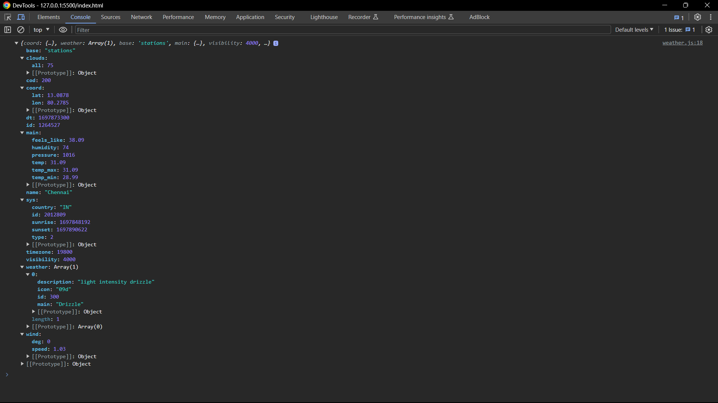

**Output of an webpage:**

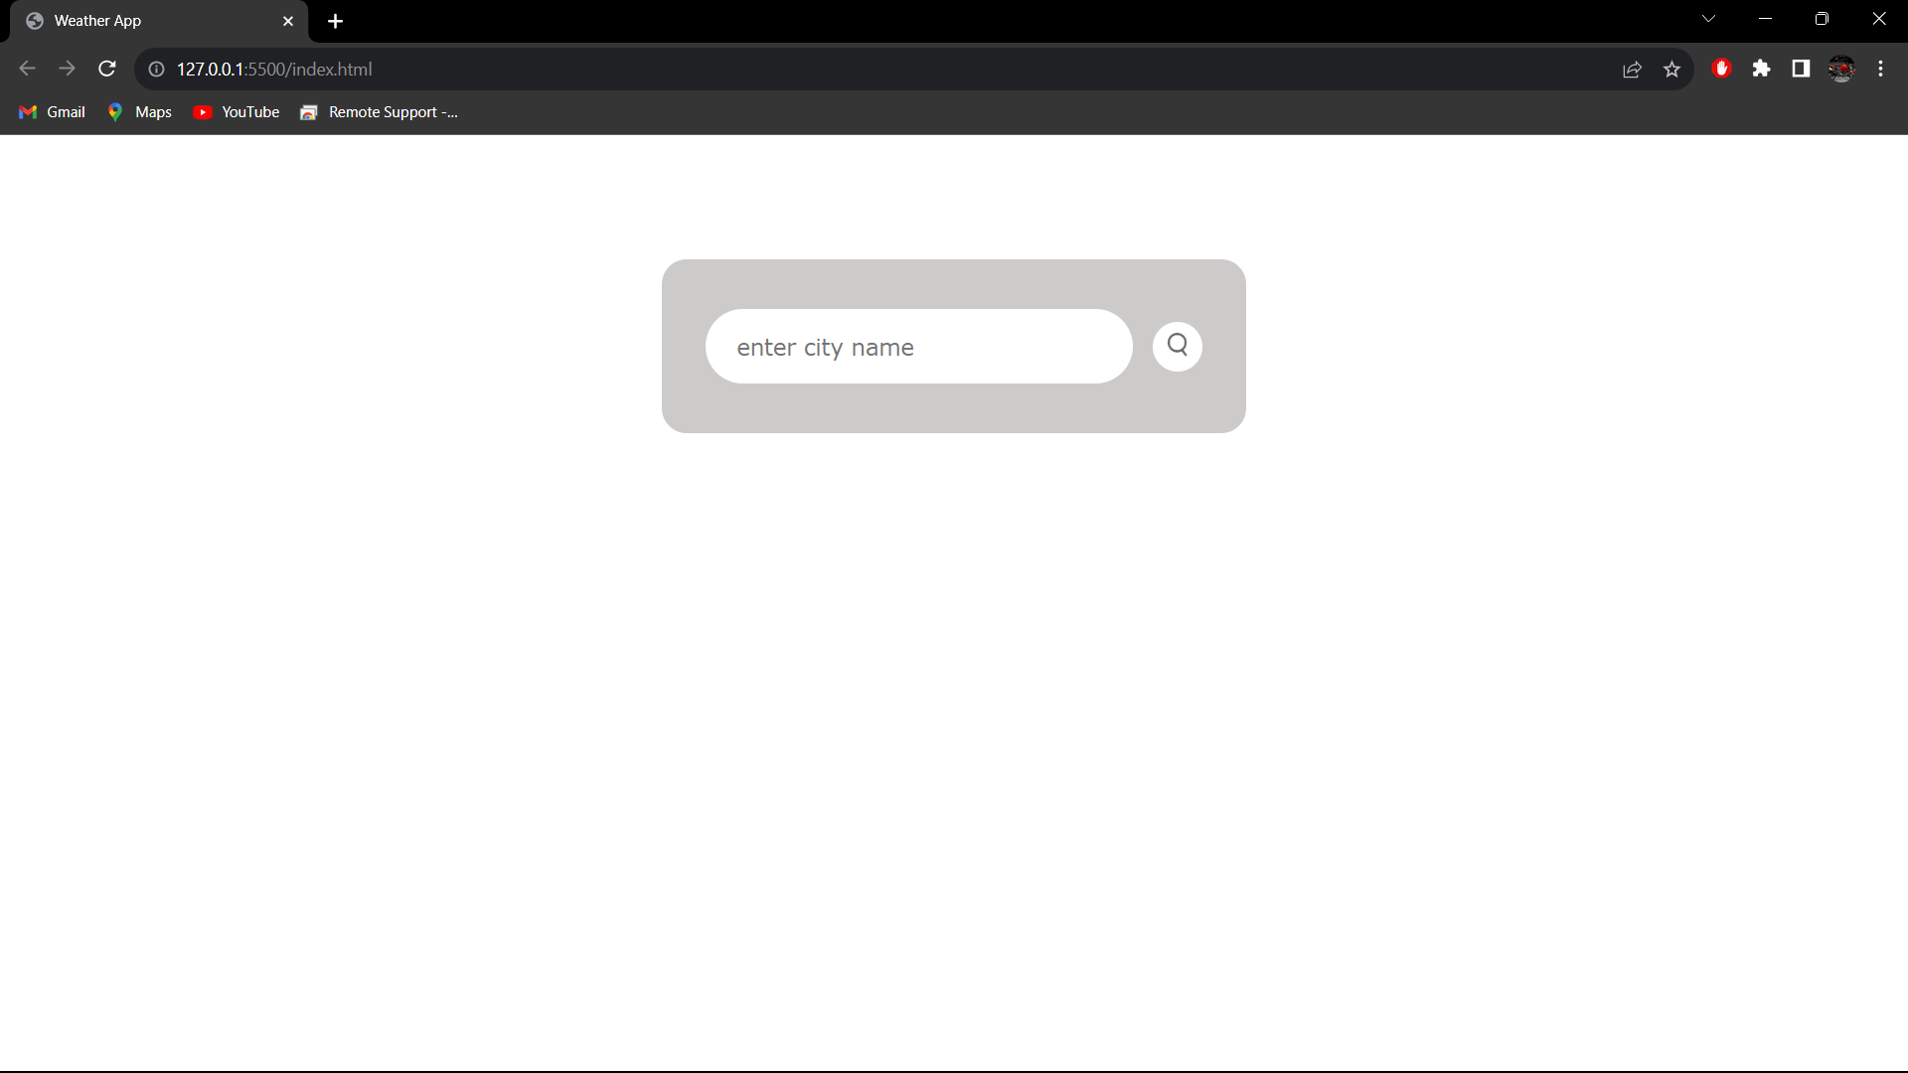

**Output:**

Step 1:Enter the city name for example Chennai

Step 2:After the city click in search icon

Step3:After clicking the icon the output will we display as

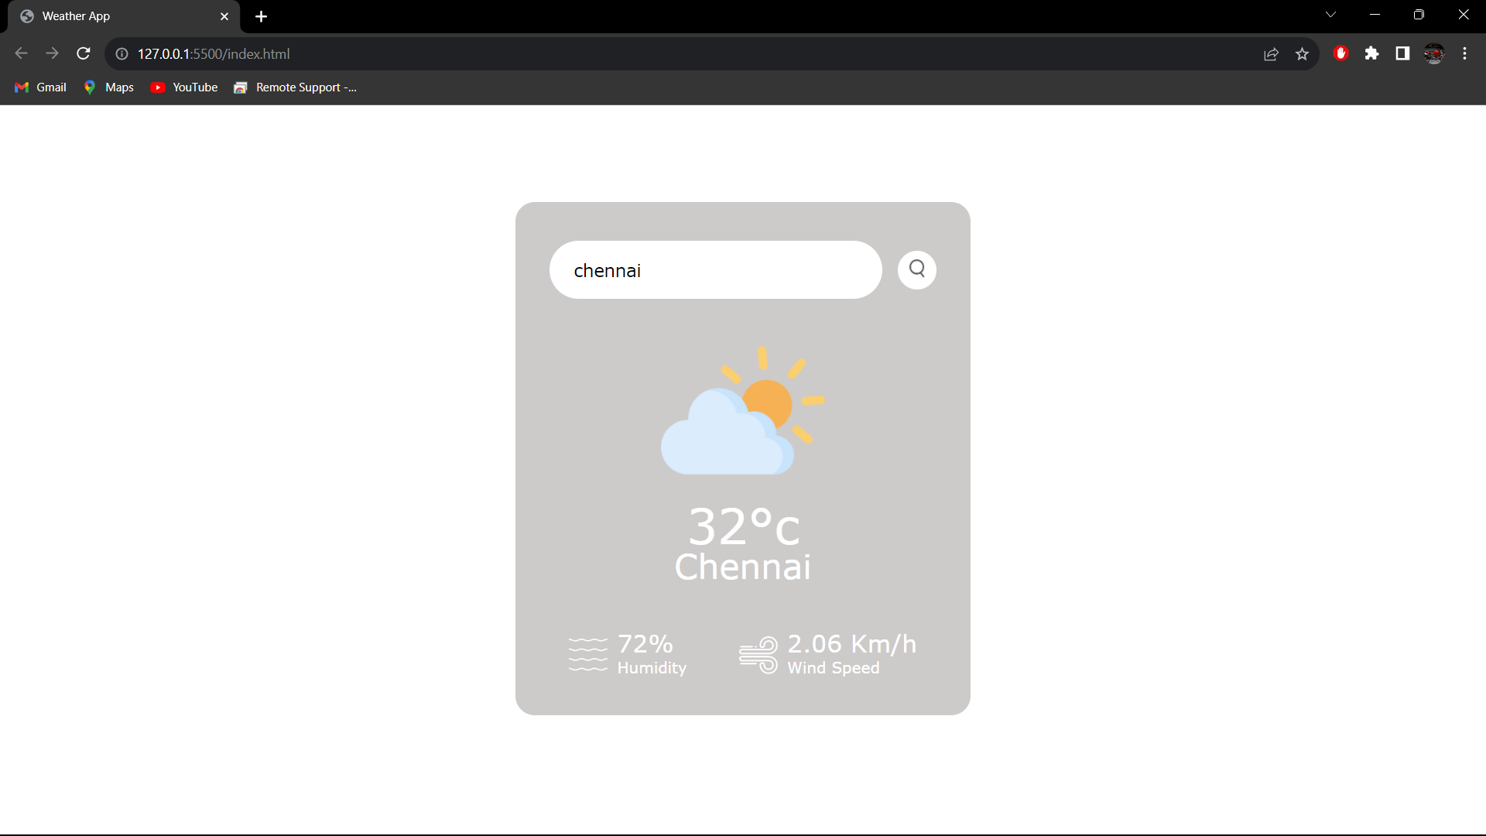

**Note:** If the not enter the city name correct then it will be display as

Invalid city name

